**Daily Scrum or Standup Meeting**

Team name: Group 8_________________________

Scrum Master: Cole_______________________

Date: 3-4-2021_______________________________

|  |  |  |  |
| --- | --- | --- | --- |
| **Team Member** | **What did you do since the last scrum?** | **What do you plan to do before the next scrum?** | **What obstacles do you have?** |
| Cole | Went deep-sea diving into the depths of React | Keep diving | I don’t remember JS very well |
| Jeremy | Got Django up and running, preliminary DB work started | Keep working on Django models and apps | None |
| Austin | Started preparing for API usage in customer interfaces | Continue with that | None |
| Logan | Started on the React tutorial | Keep working on the React tutorial | Time |
|  |  |  |  |

# Burndown

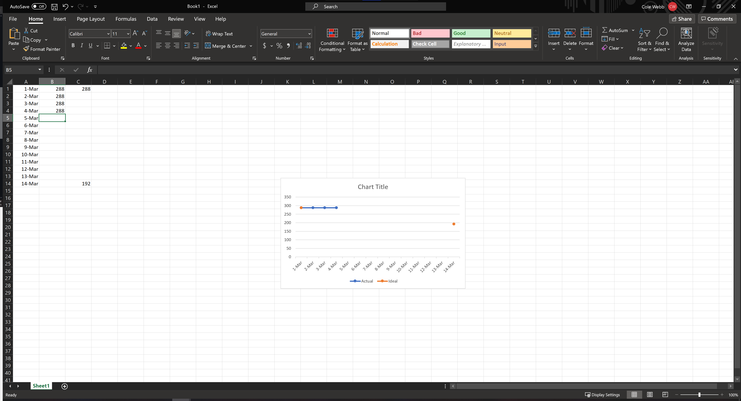

# Screenshot of you project board

